IELCE/IET – WIOA Section 243
FY 24 Competitive Grant Application

Integrated English Language and Civics Education (IELCE)/Integrated Education Training (IET)
The purpose of WIOA Section 243 IELCE programs is to provide instruction that is designed to prepare adults who are English language learners (ELL) for, and to place such learners in unsubsidized employment within in-demand industries and occupations that lead to economic self-sufficiency and integrate with the local workforce development system.

Programs receiving funds under WIOA Section 243, must implement integrated English literacy and civics education activities to help English language learners achieve competence in English through contextualized instruction on the rights and responsibilities of citizenship, naturalization procedures, civic participation, and United States history and government to help such learners acquire the skills and knowledge to become active and informed parents, workers and community members. Required components of IELCE services are as follows:
- English Language Acquisition (speaking and comprehension) and
- Literacy (reading and writing) and
- Civics education (the rights and responsibilities of citizenship and civic participation)

The Maryland WIOA State Plan has placed priority on the IELCE being aligned with Maryland’s ESL content standards taught concurrently with instruction on the rights and responsibilities of citizenship and civic participation, understanding the American systems of government, education, healthcare, and the American workplace.

In addition, programs receiving IELCE funds under Section 243 of WIOA must ensure that students in the program have access to integrated education and training (IET). Access to an IET means that students who are in Section 243 (IELCE) funded services are also able to attend an IET course, if interested; however, students enrolled in the IELCE program are not required to participate in such service.

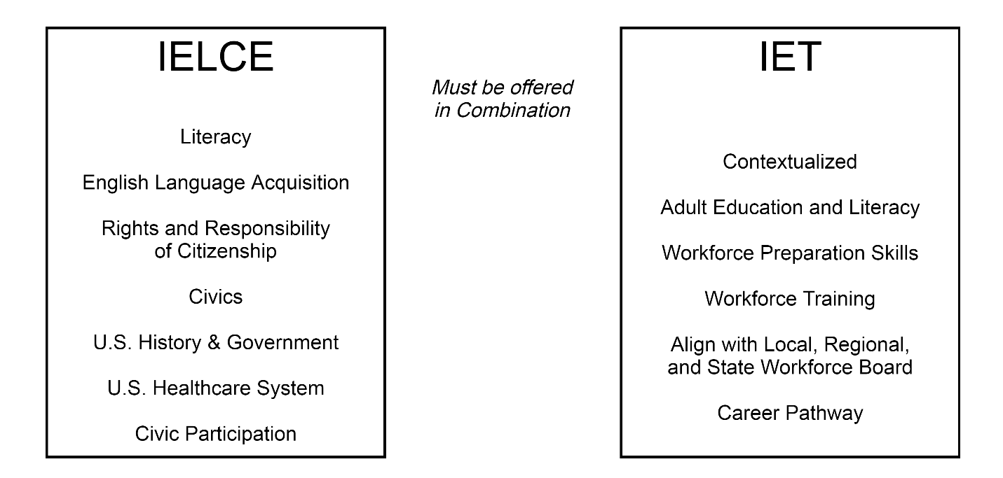
The “in combination” requirement can be met in two possible ways:
- Program provides IELCE and co-enrolls participants in an IET program offered by another provider in the WIOA Local Workforce Development Area (LWDA).
- Program provider itself offers both IELCE and the IET.

Approach #1:
Co-enrolling students in occupational training

Approach #2:
Integrated Approach (MI-BEST model)

Required components of the IET program are as follows:
- Adult education and literacy activities,
- Workforce preparation activities,
- Workforce training,
- Should align with the WIOA State and Local Workforce Plans
The IET components must be provided contextually and concurrently for a specific occupation or occupation cluster. The instruction must be aligned with the College and Career Readiness (CCR) standards and integrate workforce preparation activities.

What is Workforce training? (Must include at least one)
- Occupational skills training, including training for nontraditional employment
- On-the-job training
- Incumbent worker training
- Programs that combine workplace training with related instruction, which may include cooperative education programs
- Training programs operated by the private sector
- Skills upgrading and retraining
- Entrepreneurial training
- Transitional jobs
- Job readiness training
- Adult education and literacy activities, including activities of English language acquisition and integrated education and training programs, provided concurrently or in combination with services described in 1-7 above.
- Customized training conducted with a commitment by an employer or group of employers to employ an individual upon successful completion of the training.

Who is eligible to participate in an IELCE/IET program?

IELCE provides education services to English language learners who are adults, including professionals with degrees and credentials in their native countries that enables such adults to achieve competency in the English language and acquire the basic and more advanced skills needed to function effectively as parents, workers, and citizens in the United States. Such services must include instruction in literacy and English language acquisition and instruction on the rights and responsibilities of citizenship and civic participation. Also note: the National Reporting System (NRS) levels are not the determiners for student eligibility. Non-native English speakers, who are receiving ELA instruction and civics instruction as an integrated component of the IELCE, are still eligible to participate in the IELCE/IET even though they may have tested out of all six ELL levels in NRS.

Definition of a Recognized Credential

Certificates must recognize technical or industry/occupational skills for the specific industry occupation rather than general skills related to safety, hygiene etc. even if such general skills certificates are broadly required to qualify for entry-level employment or advancement. Examples of certificates that are not NRS reportable: ServSafe, OSHA 10, and Microsoft Office.

While local providers are not prohibited from offering such courses, they will need to offer IET training that is occupation specific in order to comply with the requirements of the WIOA 243 IELCE/IET Program.

Fund Use

In FY 20, the Maryland Department of Labor, Adult Education & Literacy Services expanded the use of IELCE/IET funds to include ESL Level 3 students to participate in IET Bridge classes. In FY 24, in accordance with the likely increase in student participation, local providers may continue use 25% up to 30% of WIOA 243 funds to run bridge classes that specifically include ESL Level 3 students. The remaining 75% to 70% of the IELCE/IET budget must be used to fund the actual IELCE/IET Program.

In addition, while the use of Title II Adult Education funds to support the IET component is not prohibited, it is not deemed best practice. It is strongly recommended that occupational training be funded through a partner.

IELCE-IET WIOA 243 Grant Application Instructions

IELCE Budget Instructions
Only IELCE and IET classes funded with the WIOA 243 Funding line will be included in this budget workbook.

Reminder: The administrative funds for IELCE must be included in the total for the 5% Administrative Cost Cap.

IELCE Class Schedule
The only NRS levels for IELCE are ESL 3 through ESL 6. The NRS level CANNOT be ESL 1, ESL 2, or any ABE level. The only budget funding line for IELCE is line 9 - IELCE/IET (Federal).

IET (243) Class Schedule
If the IET class is a Bridge class, put a check in the "Check if Bridge Only" column. The only NRS levels for IET and Bridge classes are ESL 3 through ESL 6. The NRS level CANNOT be ESL 1, ESL 2, or any ABE level.

If the funding source is budget line 9 - IELCE/IET, click on the pull down menu and choose that option. For all other funding sources, write in the specific fund name, not a general reference. Example: “Vision for Tomorrow Grant” versus “other” or “college foundation”.

Grant Application for FY 2024 IELCE/IET Program
In describing how the IELCE Program will be delivered in combination with IET, address the following:
Describe how the specific occupation or occupational cluster has been chosen such that it aligns with your WIOA Local Workforce Development Plan. Use local data to support your choice.

Describe how participants will access and participate in the IET.

Describe how the contextualized academic skills, workforce preparation, and workforce training of the IET will be of sufficient intensity and duration and has a single set of learning objectives.

IELCE includes English language instruction, including speaking, reading, writing and comprehension skills in English and Civics education that is based on the best practices and are aligned with the English Language Proficiency Standards for Adult Education. Address the following:
Explain how the delivery of services will allow adults to achieve competency in the English language and acquire the basic and more advanced skills needed to function more effectively.

Describe how the civics education component of IELCE will be offered to participants. How will participants engage in activities and lessons that increase their awareness of rights and responsibilities of citizenship and civic participation, and U.S. History and Government?

In incorporating technology into your IELCE/IET Program, address the following:
Describe how the program plans to use technology to facilitate lessons and activities.

How will technology be used to help prepare students for the desired educational and occupational outcomes?

Describe how your IET(s) will coordinate with the current local workforce development system and/or Labor Market Information (LMI). Use the chart below to provide data to help define your plan.
How will this affect the IET choice, be the first step in a career pathway, and lead to recognized credentials?

IET Data Chart
Occupational Training | Entry-Level Positions | Initial Industry  Certifications | Degree Options in Pathway

How does the IET align intended outcomes to area employer needs?

Describe how your program will fund IET.
What is the driving force behind this choice?

Who will provide resources or funding?

Describe the program strategy for recruitment and planning for sustainability for the FY 24 IELCE/IET program.
How will the program identify eligible individuals to participate in the IELCE/IET Program?

What barrier removal support services will your program provide? Include scope and intensity of services.

Who will provide the support services?

