Budget Workbook Examples Explanation

The following examples are for the purpose of illustrating allowable versus non-allowable MD Labor expenses, as well as those costs that are administrative versus those that are instructional.

The examples also show the calculation formulas all programs should use. This will provide consistency and greater accuracy as well as being able to identify potential errors in calculations. Your calculations shown do not need to be exactly as indicated here, but they should be similar to the examples provided.

Reminder: Programs can show the 5% Administrative Costs and the matching funds on one funding line or on several funding lines. These costs do not need to be calculated for each funding line individually. You are permitted to do so, but it is not necessary.

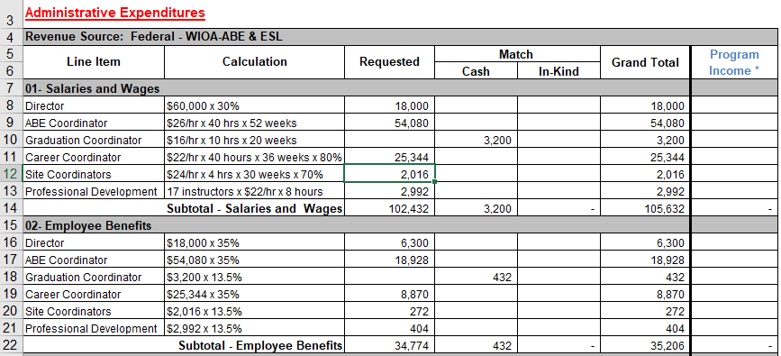

Administrative
Salaries and Wages – In most cases, the ESL and ABE/GED coordinator positions will be funded entirely from Administrative Expenditures. Other coordinator positions may be split between Administrative Expenditures and Instructional Expenditures. (See below the explanations for lines 11 and 12.)

Line 8 – If the position indicated is a salaried position, you do not need to show the hourly rate.
If the salary for a position is split between two or more funding lines, show what percentage is being funded by this funding line.

Line 9 – For positions with an hourly rate, indicate the hourly rate times the number of hours per week times the number of weeks. ($__/__ hr x __ hrs/wk x __ wks)

Line 10 – Positions such as Graduation Coordinator cannot be funded by MD Labor. Matching funds should be used to fund these positions.

Lines 11 and 12 – Some coordinator positions include direct student contact. For those positions, indicate the percentage that is administrative. (Under the Instructional Expenditures section, you will indicate the percentage that is instructional.) For positions that are part administrative and part instructional, your program will be required to submit a job description for that position if one has not been previously submitted. Your Adult Education Program Specialist will work with you to determine the reasonableness of the percentage breakdown between responsibilities that are administrative and those that are instructional.

Line 13 – Unless Professional Development is indicated on the Literacy Works or AGE funding line, it is an administrative expense that will count towards the 5% Administrative Cost Cap.

Employee Benefits
Lines 16-21 – Indicate the salary for each benefited position that you indicated under the “Salaries and Wages” section and the percent of the benefit cost. Please DO NOT list each type of benefit separately, e.g., FICA, health insurance, SUTA. Combine them into an average benefit percent by position. ($18,000 x 35%).

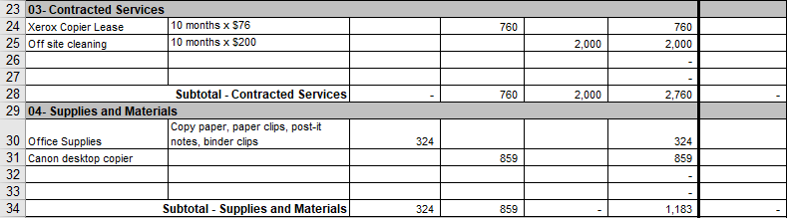

Administrative Expenditures
Contracted Services
Line 24 – The cost of leasing or servicing equipment is not an allowable MD Labor expense.

Line 25 – The cost of cleaning an off-site facility is not an allowable MD Labor expense.

Supplies and Materials
Line 30 – Office supplies do not need a break down of prices for individual items. However, a list of items should be provided to adequately indicate how the funds will be spent.

Line 31 – Equipment such as a desktop copier is an allowable MD Labor expense. If this expense is funded by MD Labor, you will need prior approval from your adult education program specialist.

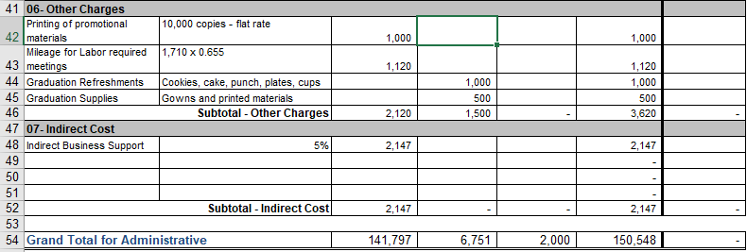
Other Charges
Line 42 – Printing promotional materials is an allowable MD Labor expense. If the cost is a flat rate for a specific number of copies, indicate that as shown in the above example.

Line 43 – Mileage is an allowable MD Labor expense for the purpose of travel for MD Labor related activities, e.g., MD Labor sponsored meetings, travel to off-site locations for instructional purposes or for orientations. The cost per mile cannot exceed the current state maximum per mile rate. However, the per mile rate dictated by your program may be lower. The lower rate set by your local institution supersedes that of the state.

Lines 44 and 45 – Any graduation or other non-instructional event expenses are not an allowable MD Labor expense.

Indirect Cost
Line 48 – Indirect costs are those costs associated with running the program. They can include support from Human Resources, accounting services, maintenance, etc. It is an allowable MD Labor expense.
The subtotals and the Grand Total for Administrative will automatically calculate.
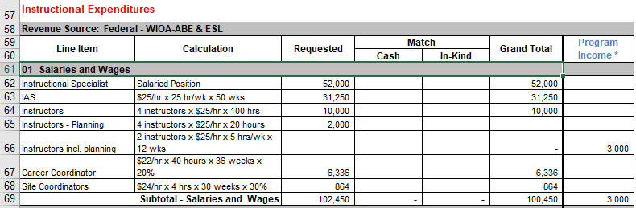

Instructional Expenditures
Salaries and Wages
Line 62 – If a position is salaried, you do not need to break down the cost.

Line 64 – Indicate the number of instructors x hourly rate x total number of hours for the semester or other time period ( ___ instructors x $___/hr x ___ hrs)

Line 65 – Indicate the number of instructors x hourly rate x total number of hours for the semester or other time period ( ___ instructors x $___/hr x ___ hrs). For planning, preparation, and/or paperwork only.

Line 66 – Indicate the number of instructors x hourly rate x hours per week x number of weeks (___ instructors x $___/hr x ___ hrs/wk x ___ wks) This shows the cost for the instruction plus the planning, preparation, and/or paperwork.
Programs that generate program income must spend those funds on adult education services and activities. It must be shown on your budget the same as any other expense.

Lines 67 and 68 – In this example, the portion of these positions that are instructional are indicated here. The remaining percentages are above as an Administrative Expenditure. The split does not need to be within the same funding line. It can be split between funding lines. (See explanation for Line 8 for more details.)

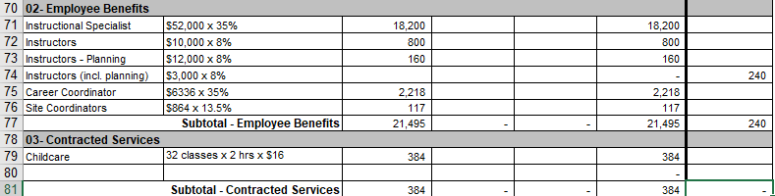

Employee Benefits
Lines 71-76 – Same as above in the Administrative Expenditures section.

Contracted Services
Line 79 – Childcare provided during classroom time is a MD Labor allowable expense. It is a Contracted Services expense, since it is childcare provided by an outside party.

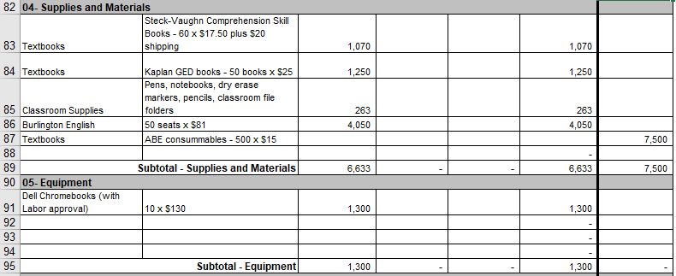

Supplies and Materials
Lines 83-87 – Include a brief breakdown of your instructional expenses. Classroom supplies do not need a break down of prices for individual items. However, a list of items should be provided to adequately indicate how the funds will be spent.

Equipment
Line 91 – Computers and any technology related equipment, other than that used for LACES data entry purposes, requires approval from your MD Labor Adult Education Program Specialist. Be prepared to explain the equipment’s purpose, cost break down, and why it is necessary.

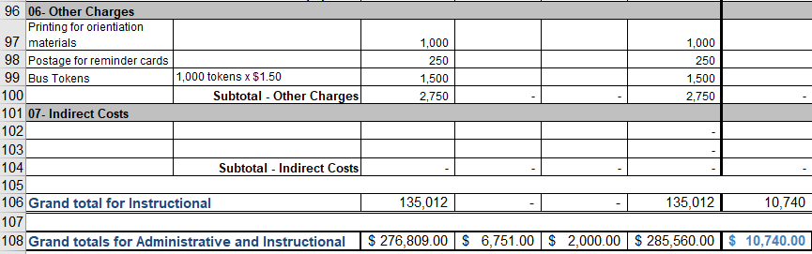

Other Charges
Lines 97 and 98 – Printing and postage for direct student related expenses are allowable as an Instructional Expenditure.

Line 99 – Bus tokens for students are a MD Labor allowable expense.

The Grand total for Instructional costs and the Grand totals for Administrative and Instructional costs will calculate automatically.

